CURRICULUM VITAE

Dr Nicholas Leonard PADFIELD FRCA FFPMRCA

Consultant in Pain Medicine and Anaesthesia Guy’s and St Thomas’ NHS Trust, St Thomas’ Hospital, Lambeth Palace Road, London SE1 7EH – 1996 to date.

The Pain Management Unit at St Thomas’ Hospital provides a multidisciplinary approach to the management of pain. Our unit comprises of medical consultants, pain fellows and anaesthetic trainees, clinical nurse specialists, occupational therapists, physiotherapists and psychologists supported by a complement of ancillary staff. We have suites of consulting rooms, gyms, classrooms, Day rooms and residential accommodation for patients attending the pain management programs. In addition we operate on a day case basis for pain relieving procedures and we use ward and operating facilities as Guys for all the implant/ neuromodulation surgery.

I see roughly 450 new patients (i.e. 10 a week) and undertake roughly 300 day case procedures and 70 neuromodulation operations (spinal cord stimulators etc;) a year. As a department we have regular educational meetings in house and organize teaching symposia throughout the year for which I have either a direct responsibility for the scientific program and organization, or a facilitatory one.
I also have a role in organizing and facilitating clinical audit projects.
I am Treasurer of the Neuromodulation Society of Great Britain and Ireland (NSUKI)

I am clinical lead in a number of research projects and am assisted by pain fellows and research assistants and have publications in the biomedical literature.
I am on the faculty of the satellite symposium held at Guys Hospital as part of the International Neuromodulation Society’s annual conference which is being held in London this year – 2011.
I am chairman and lead of the organizing committee for the sixth Guys and St Thomas Pain Symposium to be held at St Thomas Hospital Friday November 11th 2011.

PREVIOUS POSTS

Consultant Brook General Hospital and Greenwich District Hospital from 1988 to 1996. This was a hybrid post in a district general hospital, which contained two regional specialist units; neurosurgery and cardiac surgery. Referrals from these started my interest in Neuromodulation some twenty years ago. However I was working as a single handed practitioner in a district general hospital and am thus aware of the support levels in such circumstances and the frustration that goes with the lack of support and resources.

EXPERIENCE ABROAD

I did an exchange rotation as a registrar in Sydney, Australia, and have worked as a locum in the Netherlands. I have taught as a consultant in France and Italy as I have fluency in both those languages.

ACADEMIC ACTIVITY

- I have given lectures to national and international audiences on topics in Anaesthesia and Pain medicine
- I have lectured Personal Injury Lawyers at the British Library, London on ‘ When to instruct a Pain Management Expert’ (organized by Russell Jones and Walker Solicitors).
- I have co-edited and co-authored three books, one of which was awarded a BMA prize.
- I have participated and to continue to do research in pain medicine as principle investigator and as a collaborator
- I have just submitted the final draft of a chapter on ‘The Employment of Neuromodulation for patients suffering pain from cancer’, Eds Hester and Peat; Oxford Univeristy Press
- I have presented a poster on the evaluation of the Epiducer – a novel method of introducing flat paddle leads percutaneously for spinal cord stimulation at the NANS meeting December 2010
- I am lead investigator at the St Thomas’ hospital site for a multicentre investigation into the role of immunoglobulin as treatment in complex regional pain syndrome.
- I have just submitted (and had accepted for publication ) two book reviews for the British Journal Of Clinical Pharmacology
- I am in discussion with publishers for a Third edition of the Pain Clinic Manual

MEDICOLEGAL ACTIVITY

I have undertaken medico-legal work for the last twenty years. I am conversant with the new part 35 civil procedure rules. I accept roughly one hundred and fifty new instructions a year. I accept instructions for both claimant and defendant with no preference. I am occasionally instructed as a single joint expert. The bulk of the work is personal injury but I am being instructed more frequently now in negligence cases.

In addition to report writing I am now finding myself requested to organise joint conferences between myself and other medical disciplines, and simultaneous consultations with experts appointed by the other side – in an ever diversifying manner.

I have attended educational courses in medicolegal report writing, giving oral evidence in court and clinical negligence. I have given oral evidence in district, county and high courts. I am a member of the UK register of expert witnesses and have had my anonimised reports vetted.

CONTACT DETAILS

PRIVATE OFFICE
Secretary Ms Sally ANN COOK
TELEPHONE/FACSIMILE/ANSWERPHONE 020 7349 9717
Email n.padfield@btconnect.com
Web site www.drnicholaspadfield.com
Address for Correspondence:-
49 Smith Street,
London SW3 4EP
CONSULTING ROOMS:-
- Westminster Bridge Consulting Rooms,
Gassiot House,
St Thomas’ Hospital
London SE1 7EH

Telephone 020 7188 1610
Facsimile 020 7188 1611

- King Edward VII/ Sister Agnes Hospital
Beaumont Street,
London W1 G 6AA
Telephone 020 74864411
Facsimile 020 7467 4312
- The consulting Rooms,
30 Devonshire Street,
London W1G 6QA

Telephone 020 7467 4550
Facsimile 020 7467 4375

MAPS St Thomas Site

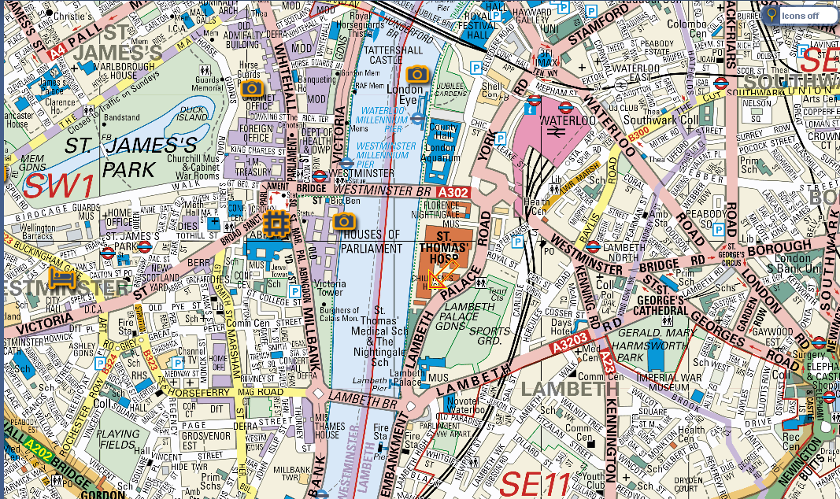

MAP KEVII Site

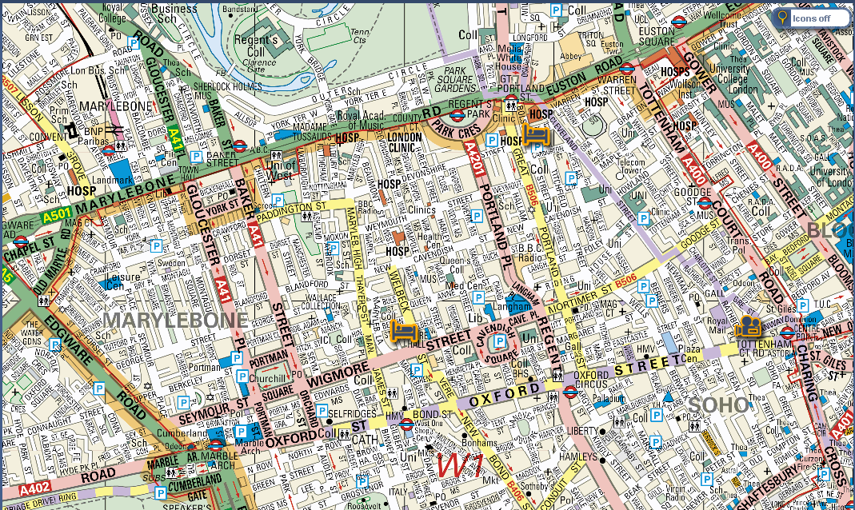

MEDICO LEGAL CHECK LIST FOR THE AVOIDANCE OF DOUBT……
Experience
I have been involved in medicolegal work and in providing Medicolegal reports since 1991. To get me started I attended BMA sponsored medicolegal courses in report writing and giving oral evidence. I also attended a three day symposium run by Lyons Davison Solicitors on WHIPLASH in 1997.
I have attended Symposia run by Solicitors on Personal Injury and recently I have attended a Day course Run by a Solicitor and Barrister on Clinical Negligence.
I am a member of the Expert Witness Registry UK and have had reports vetted.
I have attended District, County and High courts to give oral evidence, the last attendance being the beginning of June 2011.
Report Turnaround
Once a claimant has been seen for a clinical consultation, provided all the documents to be scrutinized are available I endeavour to release a ‘draft’ report within 2-3 weeks. I find this gives the interested parties a chance to correct any factual errors and saves on a lot of time consuming correspondence. Unless the circumstances are exceptional and agreed at the outset, I expect payment within three months of sending the draft when I shall then release the final and signed report.
Personal approach to medico-legal work
I endeavour to make myself reasonably available for telephone conferences and general discussion with solicitors, which can often expedite matters. I also make myself available for joint discussions with other experts, recognising that accepting instructions equates to a lot more work over time than just writing a single report.
In Personal injury cases, as I am still very active In a large Pain Medicine Department in a London Teaching Hospital, I will often make recommendations for further treatment and will recommend colleagues who can undertake this – since I personally cannot while still engaged as an independent expert.
Instructions accepted
I accept instructions as a single joint expert and have also set up joint consultations with my ‘opposite’ number. This has a number of advantages in that the claimant is assessed by both sides simultaneously. Any differences of views can then be made immediately apparent to the court as well as the areas of agreement. Having been involved for two decades in medicolegal work I am well aware of the adversarial nature of the business! But joint consultations also gives one the advantage of checking if both parties have the same documents to peruse and if there are deficiencies these can be rectified much more quickly.
I accept instructions as they come with no preferences for claimant or defendant. I would estimate therefore that the breakdown would be Equal proportions for claimant and defendant with a smaller proportion for single joint instructions (say 45:45:10). I always emphasise that my report is for the court to who I am ultimately responsible.
FEES
I am VAT registered No 912 6033 58
I charge by the hour £300 + the prevailing VAT ( currently 20%)
The breakdown of the hours typically would be:-
Consultation 1-1.5 hours
Scrutiny of documents 2-3 hours per A4 ring binder
Dictation and editing 2-6 hours

Thus a short straightforward report might be 3-4 hours and a complex one 8-10 hours.

If the report were likely to take longer I would inform the instructing party before proceeding wherever possible.

IMAGE OF DOCTOR NICHOLAS PADFIELD

