SHORT RESUME/CURRICULUM VITAE – Sigismund Wilkey

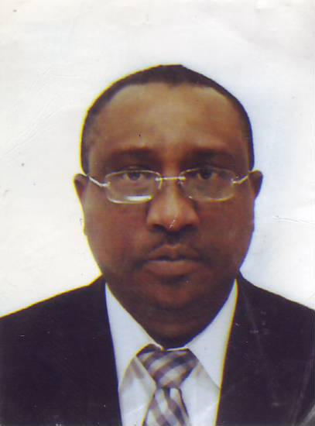
NAME: Mr Sigismund Wilkey  FRCS (England); FCEM (United Kingdom)  PgCert Focused Ultrasound (King’s College London) | Emergency Medicine Consultant  Special Interest – Focused Emergency Ultrasound
Secretary: +441707365094

Direct ; +441707365486

Mobile no: +447957 286 773

WORK E-MAIL: sigismund.wilkey@nhs.net

HOME E-MAIL: sigismund.wilkey@yahoo.co.uk

Summary of UK Experience & Posts held
I have worked in the UK for 20 years, initially I trained as a Surgeon. I changed to Emergency Medicine (A&E) Medicine in 1997, and completed the Specialist Training in 2003, and took up my appointment as a Consultant the same year.
I have written Medicolegal Reports for the last 11 years, and I am a member of the Registration Council of Medical Experts.
I developed a special interest in Focused Bedside Ultrasound (Bedside Emergency Ultrasound), and went on to do a 1 year fellowship at King’s College London. I run training courses for the College of Emergency Medicine, and have presented internationally, including Brazil & Nigeria (WACS 2010), Transforming Emergency Care in Nigeria June 2009.I use ultrasound in my day to day practice, as an extension of the physical examination, and I am very adept at Ultrasound-guided procedures.
I train on a number of Life Support Courses, including ALS(ACLS), ALERT (Acute & Life-threatening illness Early Recognition & Treatment..
I was the Undergraduate Tutor for the Medical students from UCL, and Regional Clinical Sub-Dean University of Cambridge Medical School, till I took a sabbatical in May 2010. I was also Medical Lead for Acute Medicine University of Hertfordshire (Physicians Assistant programme), till I went on sabbatical in Nigeria for a year in May 2010.
I took a 12-month sabbatical in a Nigerian University Teaching Hospital from May 2010 – May 2011. We set up the Teaching Hospital from scratch, and I modelled the Emergency Department along the lines that we have in the UK.
This has lead to the recognition of the need for Emergency Medicine as a Specialty in Nigeria, and I have since been invited by the West African College of Surgeons and the Ministry of Health to give advice on Emergency Medicine as a sub-specialty, and as a contributor to the Medical aspect of a National Emergency Response “Think Tank.”
.
PROFFESSIONAL AFFLIATIONS:
- Royal College of Surgeons
- College Emergency Medicine
- British Medical Ultrasound Society
- Member Registration Council of Medical Experts
- Medical Defence Union
- British Medical Association
- African Federation of Emergency Medicine

EDUCATION AND QUALIFICATIONS:
- MBBS 1986 University of Lagos (College of Medicine)
- FRCS (England) 1997
- FCEM (Fellow of the College of Emergency Medicine)2003
- Emergency Medicine Training: South East Thames Rotation:
  - King’s College Hospital London
  - University Hospital Lewisham
  - St Thomas’ Hospital London
- Postgraduate Certificate in Focused Ultrasound (KCL) 2007

TRAINING:
- General Surgery
- Emergency Medicine
- Focused Ultrasound
- Life Support
PRESENT APPOINTMENT:

Consultant in Accident & Emergency Medicine Queen Elizabeth 11 Hospital, Welwyn Garden City
Hertfordshire United Kingdom
ADDITIONAL POSTS Past & Present

- Head of Department A&E Delta State University Teaching Hospital (May 2010 – April 2011)
- Hospital Undergraduate Tutor (2005 -2010) (University College London Medical School)
- Regional Clinical Sub-Dean (2007 – 2010)(University of Cambridge Medical School)
- Honorary Senior Lecturer University of Cambridge Medical School (till April 2010)
- Medical Lead Acute Medicine University of Hertfordshire Postgraduate Medical School (2008-2010)
- Advanced Life Support Instructor
- ALERT Course Instructor

MISSION STATEMENT
- To strive to improve Emergency Care, with emphasis on basic care, early recognition and treatment of critically ill surgical and medical patients.
- Strive to make Point-of-Care Ultrasound a reality in all non-radiological specialties
- I would also like to be involved in multi-speciality and multidisciplinary (doctors, nurses and ancillary staff) training, at the grassroots level, and set up clinical skills laboratories, and run courses nationwide.
- Deliver quality patient-oriented service, while training juniors in the skills, attitude and knowledge needed for Emergency Medicine

